Algebra 3-4 Unit 3 Quiz 1

Name: ___________________ Block: __________

*Level 2: Graph (and shade) the following (identify at least 2 points)*



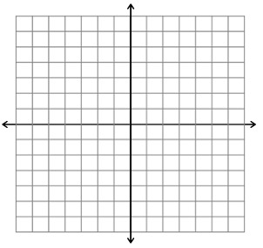

3.) $2x+4y≥8$ 4 $.) 6x-2y<12$

*Level 3: Graph (and shade) the following (darken the correct region)*





$y+1>5x$ $2.) y+3≤4|x-2|$

$y+2x<5$ $y+1≤\frac{3}{5}x$

*Level 4 Write an Equation and Graph the following.*



1. A gardener wants to plant at least 50 tulips and rose plants in a garden, but no more than 20 rose plants.